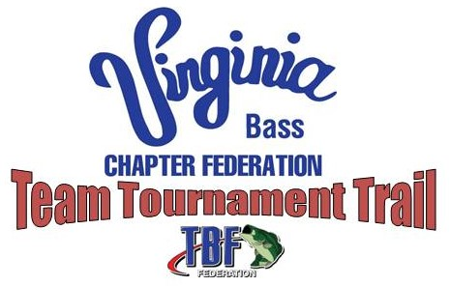

2020 Season Schedule:
North Regional: POTOMAC RIVER, 19 October 2019, Leesylvania State Park Ramp
West Regional: SMITH MOUNTAIN LAKE, 7 March 2020, Parkway Marina
South Regional: KERR LAKE, 28 March 2020, North Bend Special Events Area
East Regional: CHICKAHOMINY RIVER, 25 April 2020, Chickahominy Riverfront Park (Rte 5) Ramp
2020 State Team Tournament Trail Championship: Kerr Lake, 16-17 May 2020, North Bend Special Events Area

